Reasoning Chapter 4 (Answer Key Chapter 1)
- Hilary was examining the differences between perfect squares of numbers separated by 5. She made the following conjecture: The differences always have the digit 5 in the ones place. For example, ${17}^{2}-{12}^{2}=289-144=14$5
- Gather evidence to support Hilary’s conjecture.
- Is her conjecture reasonable? Explain.
- Denyse works part time at a grocery store. She notices that the store is very busy when she works in the afternoon from 4 to 7 p.m., but it is less busy when she works in the evening from 7 to 10 p.m. What conjecture can you make for this situation? Justify your conjecture.
- Heather claimed that the sum of two multiples of 4 is a multiple of 8. Is Heather’s conjecture reasonable? Explain. If it is not reasonable, find a counterexample.
- Prove that the sum of two consecutive perfect squares is always an odd number.
- Prove that the following number trick will always result in 6: Choose any number, add 3, multiply by 2, add 6, divide by 2, subtract your starting number.
- Judd presented the following argument: Inuvik, NWT, is above the Arctic Circle, which is at a latitude of $66°$ north of the equator. Places north of the Arctic Circle have cold, snowy winters. Winnipeg is at a latitude of 52$°$ north of the equator. Therefore, Winnipeg does not have cold, snowy winters. IS Judd’s argument reasonable? If not, identify the errors in his reasoning.

Geometry Chapter 2
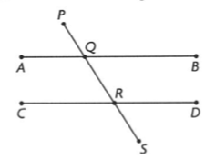
- Determine whether each pair of angle measures can be used to prove that AB $∥$ CD. State how you know.
- $∠PQA=57° and ∠DRS=57°$
- $∠AQR=123° and ∠QRD=123°$
- $∠QRC=57° and ∠DRS=57°$
- $∠BQR=57° and ∠QRD=123°$
- $∠PQA=57° and ∠QRC=57°$

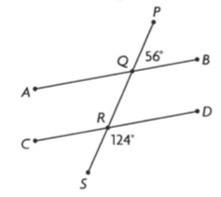
- Prove that AB $∥$ CD

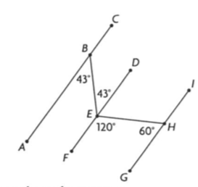
- Prove that AC $∥$ GI

- Omit
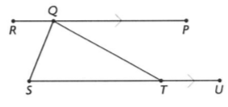
- Given $∠SQT=83°$
$$∠QTU=151°$$
RP $∥$ SU

- Determine the measure of each interior angle of a regular 11-sided polygon.
- Omit
Statistics Chapter 5
Number of Sit-ups | Number of Participants
36-40 | 1
41-45 | 5
46-50 | 9
51-55 | 15
56-60 | 23
61-65 | 26
66-70 | 22
71-75 | 14
76-80 | 8
81-85 | 4
86-90 | 2
- During Fitness Awareness Week, data on the number of sit-ups completed by the participants was collected.
- Determine the mean and standard deviation for the set of data.
- Is the data normally distributed? Explain.
- Do you think that a set of data for a different group of participants would be similar? Explain

- The flight between Vancouver and Winnipeg has a mean time of 156 minutes, with a standard deviation of 3.5 minutes. Assuming that the flight times for this trip are normally distributed, determine approximately what percent of the time you could expect the flight time to be:
- Less than 156 minutes
- Between 149 and 156 minutes
- Between 152.5 and 163 minutes
- Over 163 minutes
- Treena and Maggie both wrote a provincial exam in mathematics. Treena wrote in January, and Maggie wrote in June. Their results are given below.
Name | Mark | Provincial Mean | Standard Deviation
Treena | 84% | 71% | 5.3%
Maggie | 82% | 66% | 6.2%
- Determine which girl’s result is better.
- If the results of each exam are normally distributed, what percent of people who wrote the exam in January scored better than Treena?
- A study of 500 Calgarian taxpayers revealed that 24.1% of these taxpayers make charitable contributions. The study was considered accurate plus or minus 5%, 9 times out of 10. In a particular year, there were 827, 120 taxpayers in Calgary.
- Determine the projected range of the number of Calgary taxpayers who would make a charitable donation that year.
- If the study were conducted using a sample of 1000 Calgarians using the same confidence level, how would the projected range of Calgarians who will make charitable donations be affected? Explain.
- An Ipsos-Reid study determined that only 28% of online youth consider themselves to be very skilled or expert at using the internet, with the remaining youth identifying themselves as fairly skilled. More than 1200 online interviews, of Canadian youths aged 12 to 17, were completed. Results are considered accurate to within $±$ 2.8%, 19 times out of 20.
- Determine the confidence level and confidence interval for the study.
- Suppose that there are 68, 520 youth, between 12 and 17 years old, in a particular city. State the range of these youth who consider themselves expert at using the internet.

Linear Inequalities, Systems of Equations, Optimization Chapter 6

- Tran has made a plan to help him study for his math exam.
- He has broken the material that he has to study into two parts: part A and part B and has, at most, 2 hours every evening over the next week to study.
- He wants to spend at least twice as much time studying for part A as for part B
Show graphically all the possible combinations of time that Tran can study for each part. Choose three possible combinations. Explain your choices.
- These statements describe a solution region for a system of linear inequalities:
- The intersections of its three boundaries are (0,4), (6,1), and (0, -2).
- The boundary that is farthest left is dashed and vertical, and it intercepts the x-axis at (0,0).
- The boundary at the top is solid, with a y-intercept of 4 and a slope of -1/2
- The boundary at the bottom is solid, with a slope of ½, and an x-intercept of 4.
- The solution region is found in two quadrants.
Use these statements to identify the system of linear inequalities, and then graph the system.
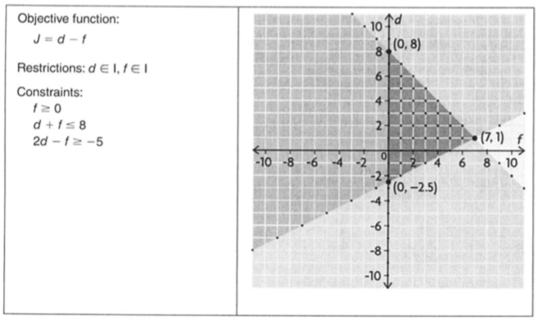
- The model below could be used to solve an optimization problem. What points in the feasible region result in the minimum and maximum values of the objective function? Explain how you know.
- Lyle is replacing light bulbs in his apartment:
- His is using energy-saving bulbs and regular bulbs, and wants to use 21 or fewer bulbs altogether.
- He wants no more than 18 engergy-saving bulbs and at least 2 regular bulbs.
- The energy-saving bulbs cost $5.95 each, and the regular bubls cost $7.85 each.
What is the most Lyle can spend on replacement bulbs? How many of each will be used?

Rates, Scale Factor, Chapter 1 (Answer Key Chapter 8)
- For each of the following, which is the greater unit rate?
- #3.25 for 526 mL or $8.45 for 1.2L
- 45 km/h or 30 mph
- a) Nuri is researching the fuel efficiency of pickup trucks. He found a website that advertised a hybrid pickup truck with a fuel efficiency of 22 mpg for highway driving. He found another website that advertised a pickup truck with a fuel efficiency of 10 km/L for highway driving. Which truck has a better fuel efficiency? Explain how you know. b) Describe a different strategy you could have used to determine the better fuel efficiency in part a).
- a) Draw a graph to represent hiking 500 m from a campground in 10 minutes, stopping for 5 minutes, hiking another 400 m away from the campground in 8 minutes, and then hiking back to the campground along the same trail in 15 minutes. Where appropriate, assume you are travelling at a constant rate on each part of your trip. b) Explain how each slope on your graph represents a rate.
- Adrienne read that she can burn 236 Cal by bicycling at 10 mph for 1 h or 502 Cal by bicycling at 14 mph for 1 h. How long would she need to bicycle at 10 mph to burn as many Calories as she would by bicycling at 14 mph for 1 h?
- The Saamis Tipi was built for the 1988 Olympics in Calgary and then moved to Medicine Hat. Its height is 215.0 ft. The diameter at its base is 160.0 ft. A manufacturer wants to make a replica model for a display that is 1.5 ft high.
- What scale factor, to the nearest thousandth, would the manufacturer need to use for the model?
- What would be the diameter at the base, to the nearest tenth of a foot?
- A company ships its sports equipment in similar boxes that are two different sizes. The red box is a right rectangular prism with the dimensions 60 cm by 30 cm by 21 cm. The blue box has dimensions that are related by a scale factor of 2/3.
- What is the volume of the red box?
- Determine the volume of the blue box, without using the formula for volume.
- What ratio compares the surface area of the blue box to the surface area of the red box?
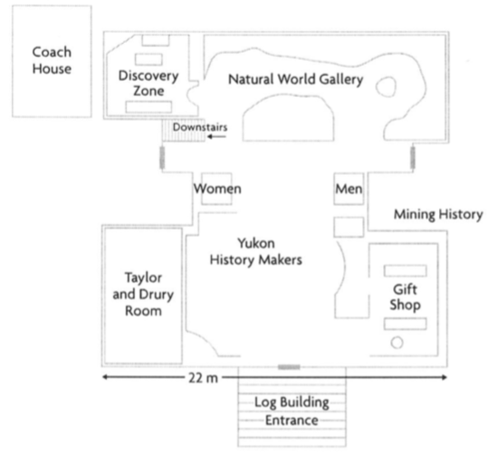
- The floor plan of the MacBride Museum in Whitehorse is shown. The distance across the front is 22m.
- Estimate the area of the main building. Explain your strategy.
- Estimate the dimensions of the coach house.
- Use a scale ratio of 1:90 and your estimated dimensions to draw a floor plan of the coach house. Label the sides with the dimensions.

- Omit
Quadratics Chapter 7

