**Exponents and Logarithms**

1. Sketch a graph of

a)  b) 

Restrictions: Restrictions:



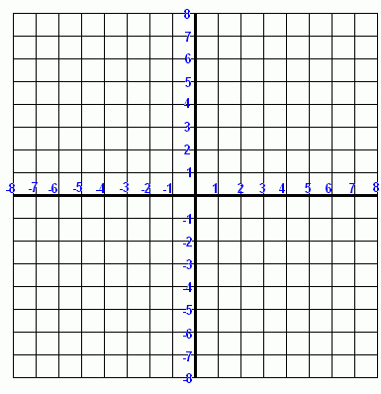

2. Use transformations to sketch the graph of



$$y=-\log\left(x+4\right)-3$$

Determine the equation of the asymptote.



3. Exponential form Logarithm form

a)  _______________________



b) _________________ 



c)  _______________________



d) _________________ 



**Laws of Logs**

 _______________________________________________________



 _______________________________________________________



 _______________________________________________________



 ________________________



**Change of Base Law**  _________________________________



1. Evaluate  ________________________



2. Write as a single logarithm:  ____________________________



3. Estimate, then use your calculator to determine the value of . _____________



Solve:

1.  2. 



Solve:

a) 



b)





c) Determine the time in years it will take an investment of $500 to double when it is invested in an account that pays 2.5% annual interest, compounded semi-annually.



d) A sample of soda water has a pH of 3.6. A sample of vinegar has a pH of 2.8.

i) Which sample is more acidic?

ii) How many times as acidic is the sample?

