Math 8 Schroeder
Name: ________________________

Chapter 6 - Geometry

Test Date: ________________________________________

To do:

6.1 – Nets of 3D Objects
- Complete Notes ⃝

6.2 – Surface Area
- Complete Notes ⃝

6.3 – Volume
- Complete Notes ⃝
- Quiz 1

6.4 – Drawing 3D Objects
- Complete Notes ⃝

6.5 – Rotating 3D Objects
- Complete Notes ⃝
- Quiz 2

Complete Chapter Assignment ⃝

Write Unit Test ⃝

Math 8 Lesson 6.1 – Nets of 3D Objects Schroeder

A net is a __________________________________ that can be used to build a 3D solid. A net shows all the faces of an object in a flattened form. The faces are the part that would be _______________________________ on the outside of an object.
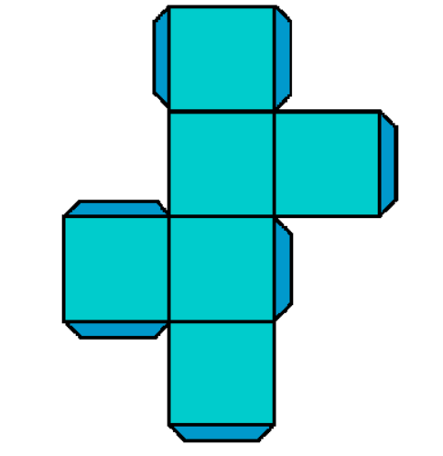
Different nets can represent the same 3D object.
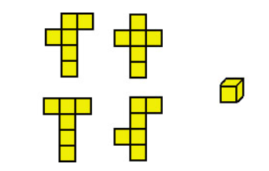
A net can be used to make an object called a _________________________________, which has faces that are polygons such as triangles and rectangles. Prisms and Pyramids are types of polyhedrons.
Examples: Identify the 3D objects for the following nets.
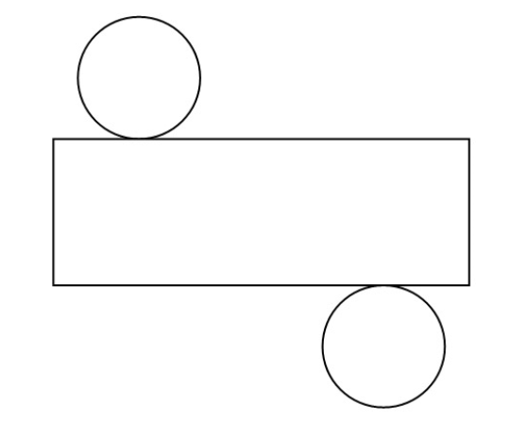
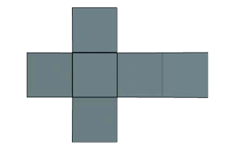
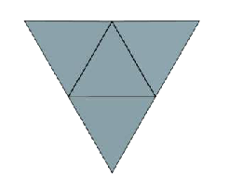
Math 8 Lesson 6.2 – Surface Area Schroeder

To find the surface area of 3D solids, you’ll need to find the area of each of the surfaces and _________________________ them together. This can be done by using some of the following formulas:
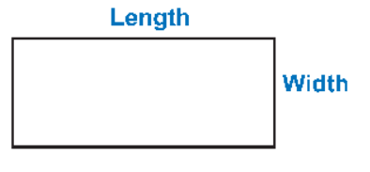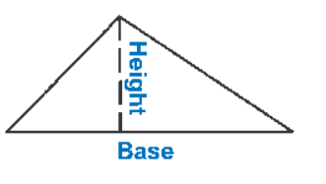

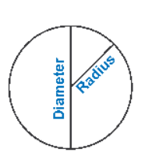

To find the surface area it is helpful to draw the net, identify the shapes of all the faces, identify the formulas, calculate each face and add for the total.

Examples: Find the following surface areas.

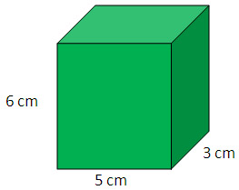

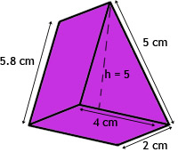

A ___________________________ has only 3 surfaces. The two congruent bases and the curved surface. When you lay a cylinder flat, the curved surface forms a ______________________. The length of the rectangle is the same as the circumference of the base. Hence we use the following formula:

Example:
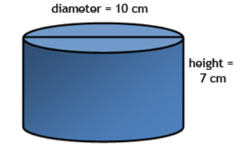

Math 8 Lesson 6.3 – Volume Schroeder

Volume can be thought of us the _____________________________________________ that an object occupies. Volume includes a third dimension, such as height or depth. The units of measurement for volume involve cubic units.

To find the volume of certain types of objects, such as cubes or cylinders, we find the __________________________________ and then multiply it by the height. Here are some example formulas:

Examples: Find the volume.

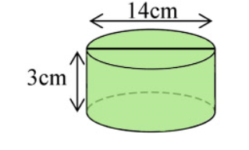

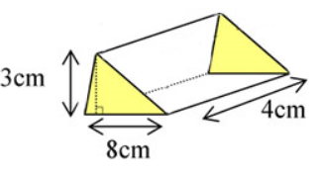

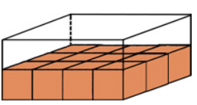

Math 8 Lesson 6.4 – Drawing 3D Objects Schroeder

1D

2D

3D

Multiview Drawings are drawings that show multiple different sides of a shape, also known as ____________________________________________. For example:

Isometric Dot Paper is when the lines of dots have been off-set so they make it easy to illustrate 3D objects. Horizontal lines on the real shape are shown as ______________________ lines on the dot paper.
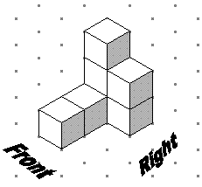

Math 8 Lesson 6.5 – Rotating 3D Objects Schroeder

There are 3 different directions for rotation:
Horizontal -

Vertical -
Left/Right –

